**B. Studies and Results**

*B.1. SARS-CoV-2 Mac1 macrodomain inhibitors*

We successfully delivered the principal aim of this discovery program: the identification of leads that potently inhibit the SARS-CoV-2 nsp3 Mac1 macrodomain. We executed a fragment-to-hit campaign using a pharmacophore-based approach which identifies salient interactions from crystallographic fragment screen (**Figure 1**).

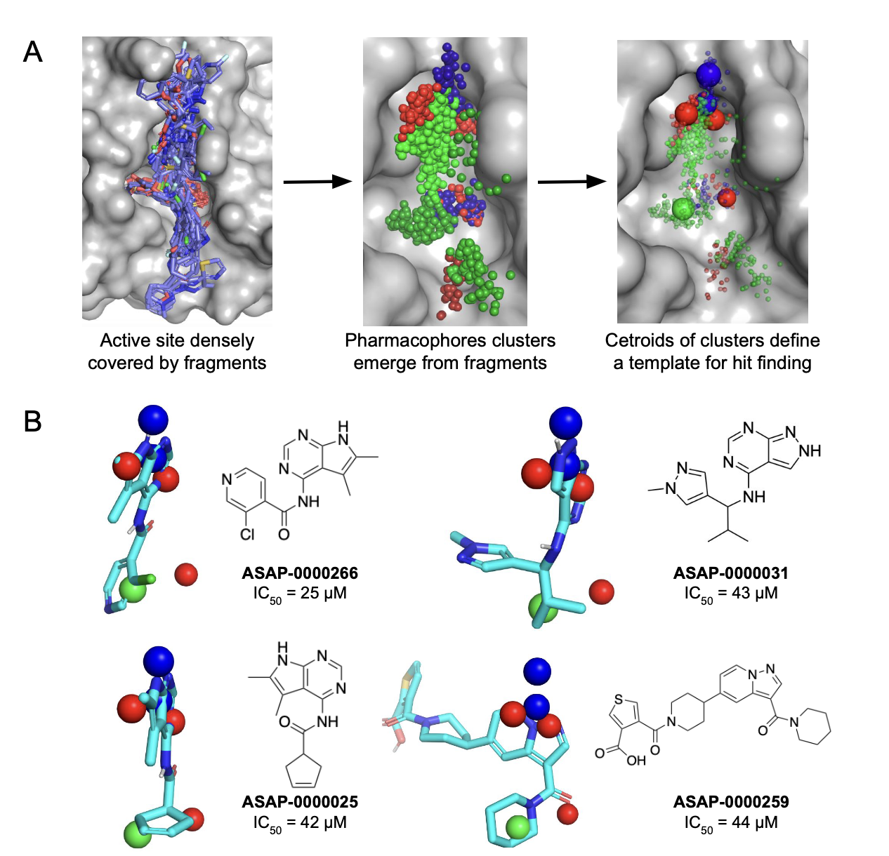

***Figure 1: Pharmacophore identification enables fragment-based hit discovery for SARS-CoV-2 nsp3 Mac1 macrodomain.*** *(A) Conversion of fragments into pharmacophore clusters. The red, blue and green spheres corresponds to hydrogen bond acceptor, donor and hydrophobic pharmacophores. (B) Selected hit molecules superimposed on the identified pharamcophores.*

We elaborated the hits with iterative library chemistry-driven designs to realise step-changes in potency (**Figure 2**). Learnings from different vectors are then combined to realise potent inhibitors (**Figure 3**). Crucially, these inhibitors are cell permeable and soluble, thus are robust tool compounds to enable further studies to interrogate the relationship between Mac1 inhibition and antiviral effect.

As the Antiviral Core was unable to identify in vitro cellular antiviral models capable of driving lead optimization in order to progress this program fully to Project 5 (Lead Optimization), we have paused this program. We are in the process of drafting a preprint to share our learnings, and have made all chemical structures, biochemical data, X-ray structures, ADMET data, and antiviral data publicly available for this program. As the QCRG AViDD Center is still pursuing this target (suggesting they could use in vivo efficacy to drive lead optimization), we have briefed them directly on our learnings and shared all data with them on this program.

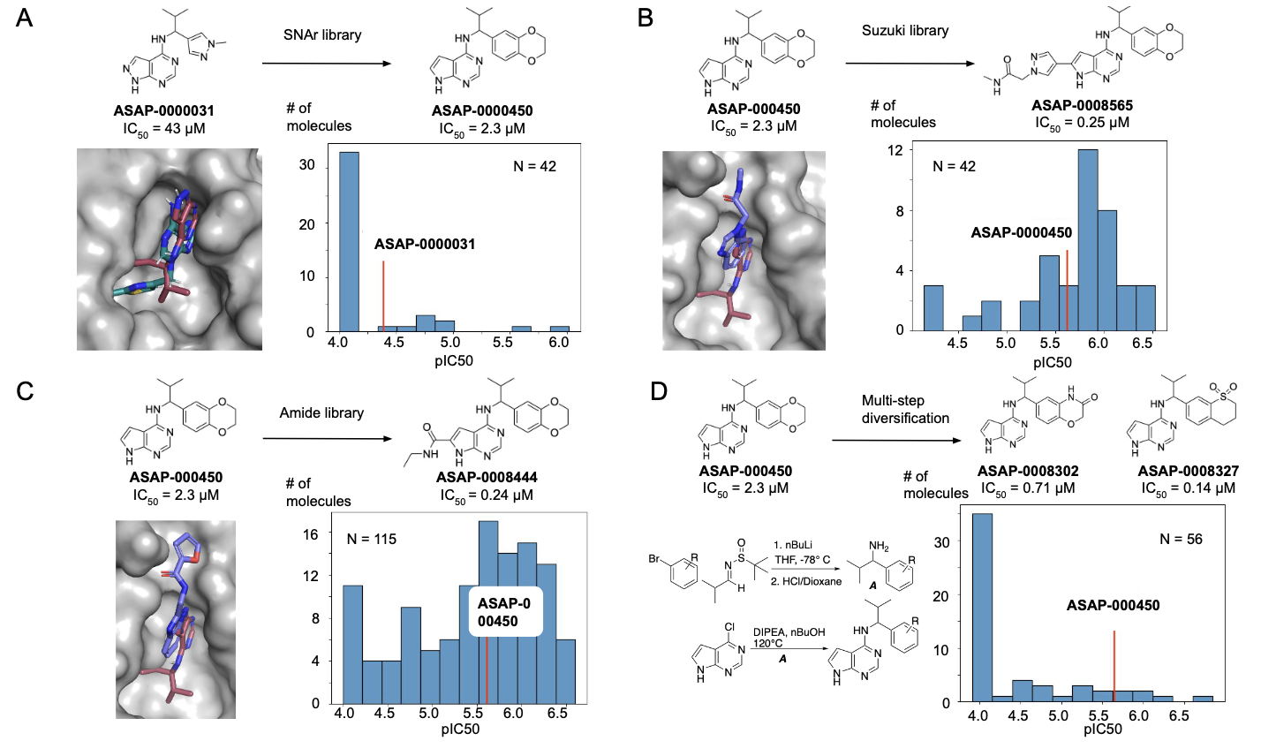

***Figure 2: Hit-to-lead chemistry via library chemistry in pursuit of SARS-CoV-2 nsp3 Mac1 macrodomain inhibitors.*** *We designed parallel medicinal chemistry libraries based on (A) SNAr, (B) Suzuki, and (C) Amide chemistries to realise step change in potency. (D) shows a multistep library which enables variations in the the benzodiaoxane motif. The crystal structural overlays show the superposition of fragments which provide inspiration for library design.*

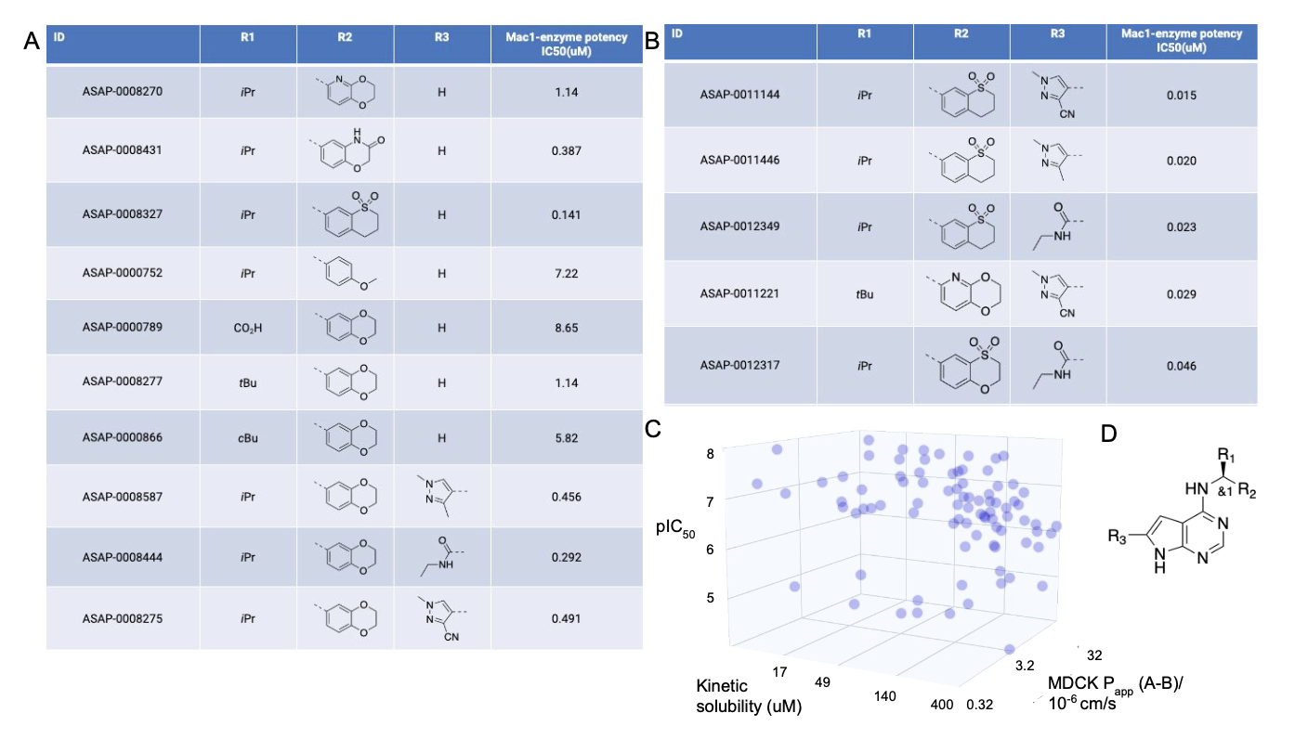

***Figure 3: Combining structure-activity relationship furnishes potent and permeable SARS-CoV-2 nsp3 Mac1 macrodomain inhibitors.*** *(A) shows key variations in one substituents around the scaffold (potency values are reported for the racemic mixture), whilst (B) shows synergistic combinations (reported as single bioactive enantiomer). (C) shows potency as a function of permeability and soluablity, revealing no inherent tradeoff. (D) shows a schematic of the scaffold.*

*B.2. EV-D68/A71 3C protease non-covalent inhibitors*

We have made substantial progress in identifying non-covalent leads which inhibit the 3C protease of EV-D68 and EV-A71 (essential criteria of the lead transition profile), prototype picornaviruses of pandemic potential. Enterovirus 3C proteases (3Cpro) are cysteine proteases with typical chymotrypsin-like fold with a catalytic triad of Cys, His, and Glu. They are responsible for polyprotein processing making 7 cleavage sites. Rupintrivir, an inhibitor of human rhinovirus 3C protease, has proven to be clinically efficacious in challenge studies, providing clinical proof-of-concept that 3C protease inhibition is likely an efficacious mechanism for antivirals directed at picornaviruses. However, Rupintrivir is a covalent peptidomimetic inhibitor with poor physicochemical and drug-like properties. In this subproject, we start from a crystallographic fragment screen to deliver non-covalent non-peptidic lead inhibitors.

Fragment overlay onto the binding mode of Rupintrivir allowed us to locate key binding hotspots that can be engaged (**Figure 4**). This enabled us to design structurally distinct classes of putative inhibitors. The first class of inhibitors contains an isoquinolone scaffold (**Figure 5**). Although they display responsive Structure-Activity Relationships and mid-nM biochemical potency, we are deprioritising this series because of its selectivity towards EVD68 and challenges in confirming binding pose with structural biology. We also progressed two backup series using a fragment-merging approach, arriving at inhibitors with biochemical potency which we are currently optimizing (**Figure 6**).

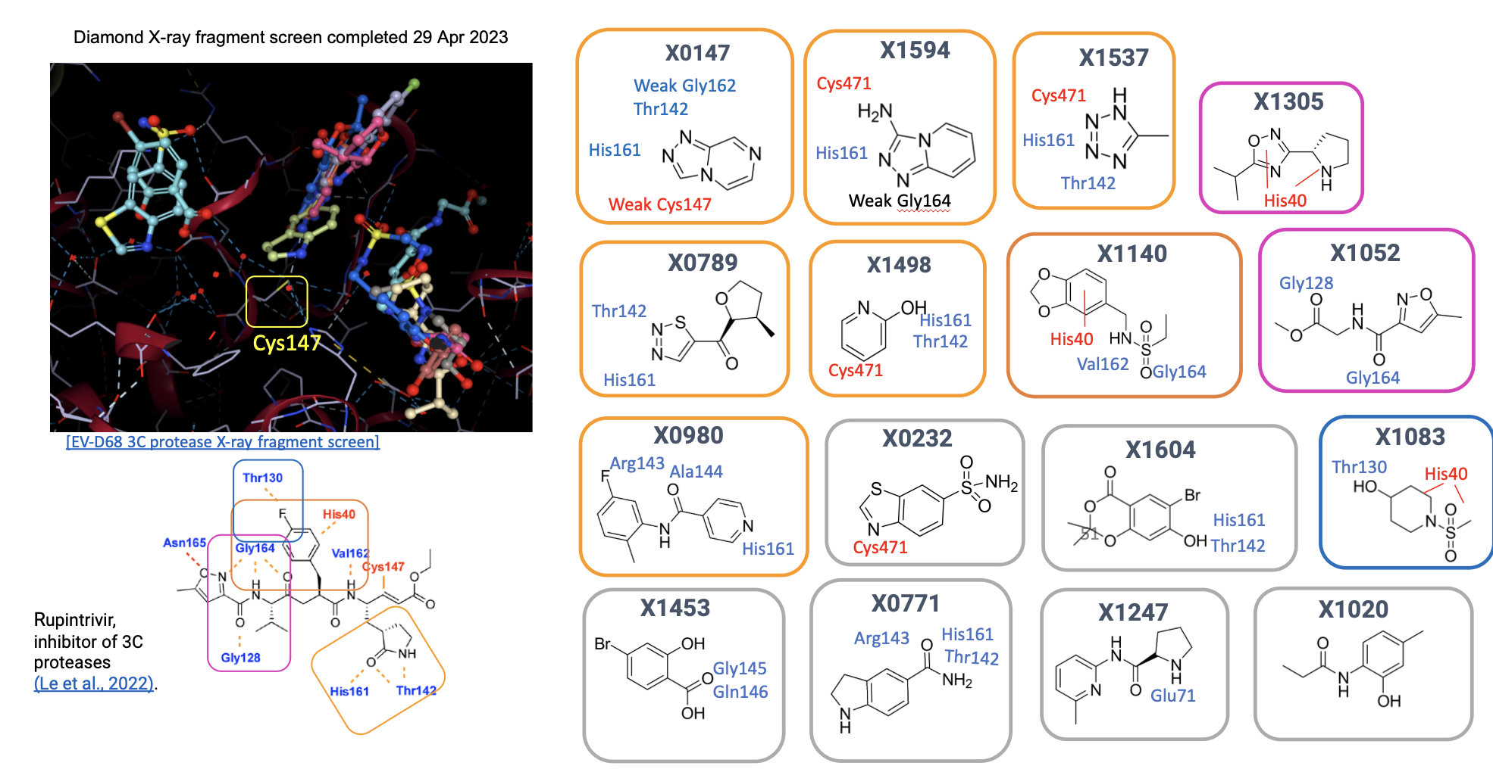

***Figure 4: Fragment-enabled structure-guided discovery.*** *Structure-based analysis of salient binding interactions by overlaying fragments onto the binding mode of known inhibitor Rupintrivir.*

*B.3. DENV/ZIKV NS2B/3 protease non-covalent inhibitors*

We have made substantial progress in identifying non-covalent leads which inhibit the DENV-2 NS2B/3 protease (essential lead transition profile), and ZIKV NS2B/3 protease (desired) prototype flaviviruses of pandemic potential. Flavivirus NS2B/3 proteases are series proteases with trypsin-like catalytic triad consisting of His51, Asp75, and Ser135, responsible for polyprotein processing, making all cleavages on the cytoplasmic side of the polyprotein. Following a fragment screen done by Project 2, we employed machine learning to identify key pharmacophores in the binding site (**Figure 7A**).

We discovered 4 chemical differentiated hit series (**Figure 7B**) with acceptable physicochemical properties. In particular, the ASAP-0021029 scaffold is structurally enabled, and has acceptable potency across both ZIKV and DENV-2 proteases. Champion compounds in the series already attained low nM biochemical potency against ZIKV protease (**Figure 7C**), and have responsive and optimisable structure-activity relationships. The X-ray structure of ASAP-0021029 in the binding site of ZIKV NS2B/3 confirms active site engagement (c.f. **Figure 7C**, right), as well as reveals vectors for further optimisation.

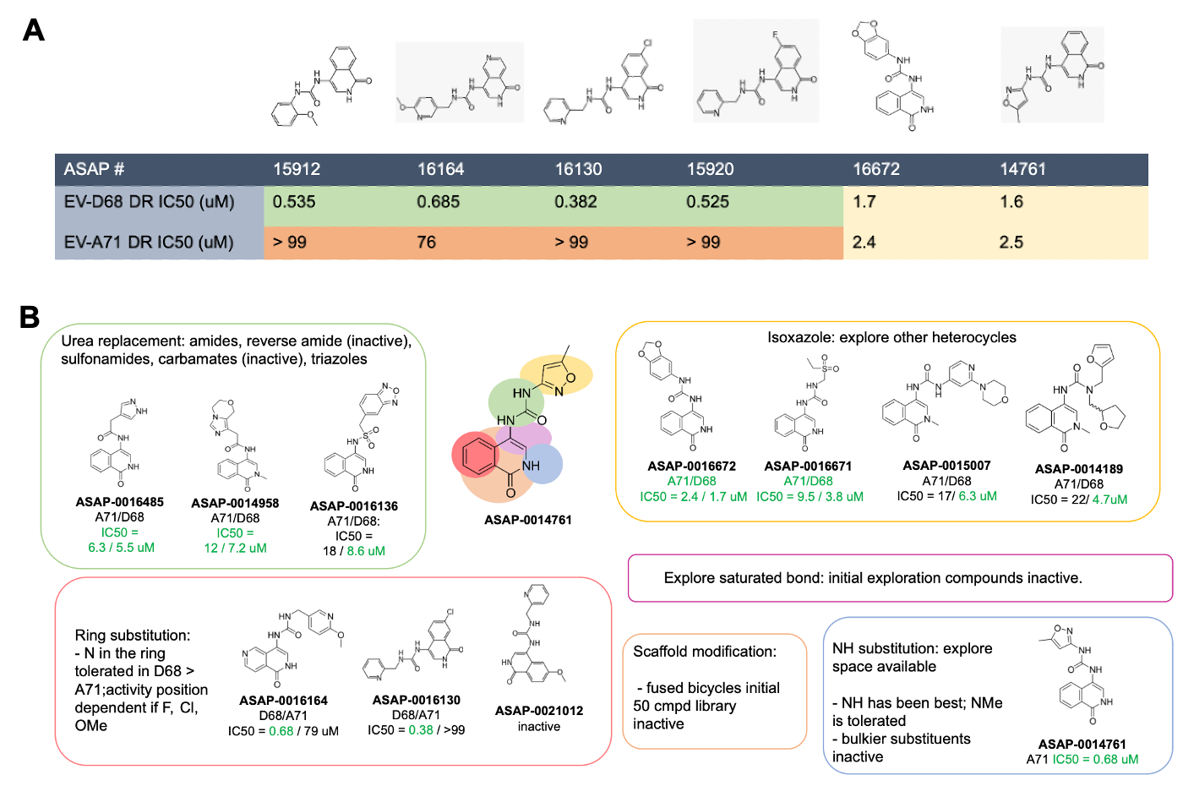

***Figure 5: Potent EV 3C protease inhibitors with an isoquinolone scaffold.*** *(A) Leaderboard of potent compounds with mid-nM potency. (B) Schematic showing structure-activity relationships.*

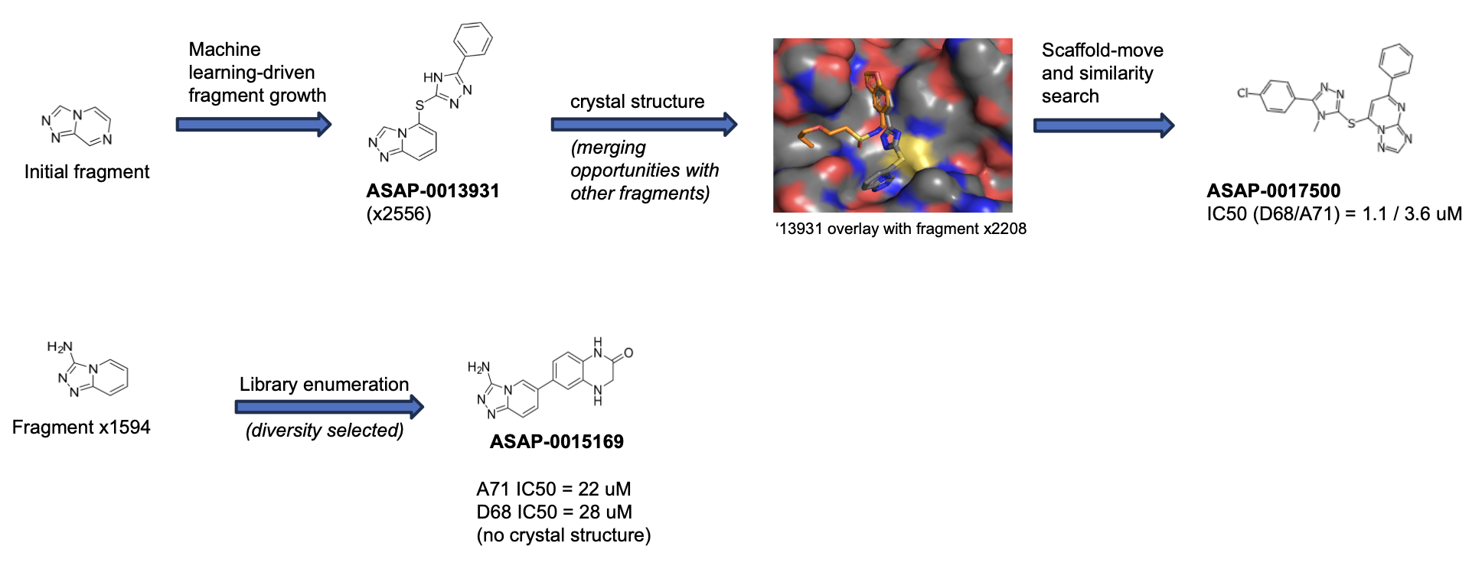

***Figure 6: Fragment-merging led to a distinct series of EV 3C protease inhibitors.*** *The top and bottom panels show a fragment elaboration approach to chemical matter generation.*

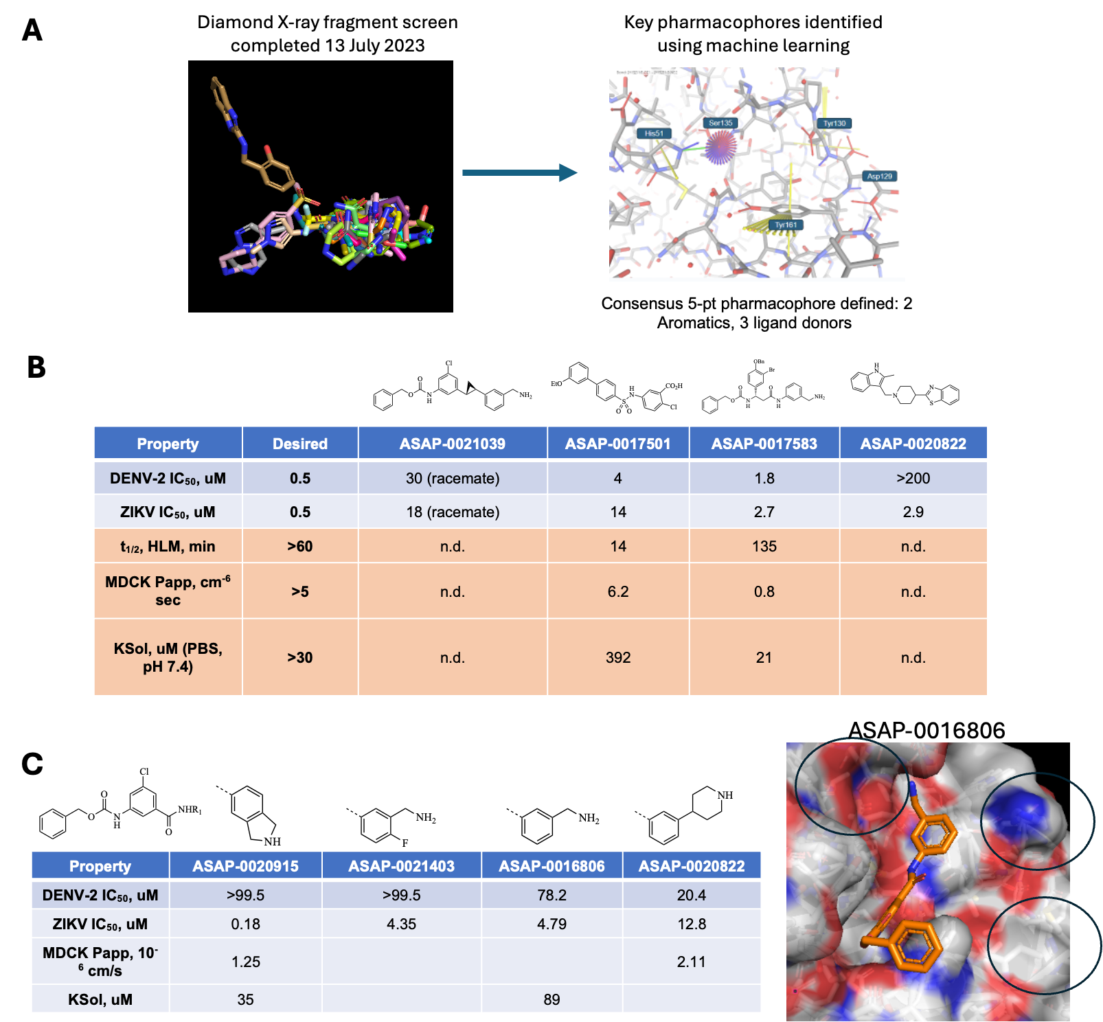

***Figure 7: Fragment-based design of ZIKV/DENV NS2B/3 inhibitors.*** *(A) We employed machine learning to identify key pharmacophores from fragment screen. (B) Initial hit finding led to 4 distinct chemical series. (C) We obtained responsive SAR and nM potency against ZIKV protease, and crystal structure of compound with ZIKV NS2B/3 confirms active site engagement as well as highlights regions for further optimisation (black circles).*

*B.4. SARS-CoV-2 N protein nucleocapsid modulators*

We have made substantial progress in identifying compounds that modulate the assembly of SARS-CoV-2 N protein (nucleocapsid). Starting from a fragment screen of the C-terminal domain (**Figure 8A-B**), we design compounds that elaborate on fragment hits. Our design strategy focuses on bridging the two binding hotspots revealed by the fragment screen (**Figure 8A**). Elaborations of fragment 361 (**Figure 8C**) led to a hit series that displays nM potency in Virus-like Particle (VLP) assay as well as antiviral assay.

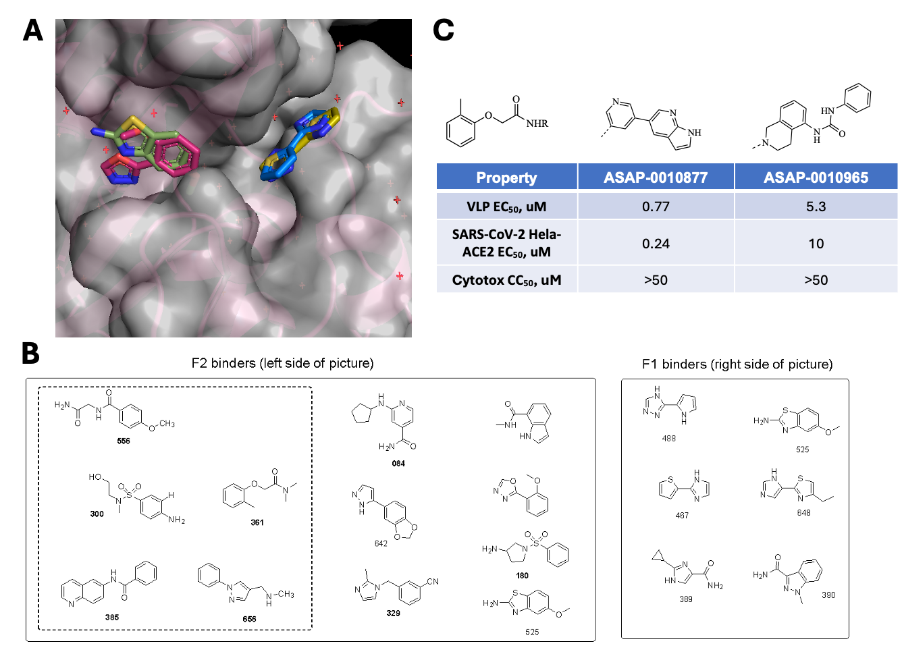

***Figure 8: Fragment-based design of SARS-CoV-2 N protein nucleocapsid binders.*** *(A)-(B) Crystallographic fragment screen shows binding hotspots. (B) Hit chemical matter with nM potency against virus-like particle assay and SARS-CoV-2 antiviral assay.*

**C. Significance**

*C.1. SARS-CoV-2 nsp3 Mac1 macrodomain inhibitors*

The significance of this project is discovering chemical matter that engages with a novel mechanism of action directed at SARS-CoV-2. New mechanisms of action which are distinct from current therapies are needed to pre-empt resistance. SARS-CoV-2 nsp3-mac1 is a macrodomain with ADP-ribosylhydrolase activity which is hypothesized to modulate host immune response. Upon infection, interferon-mediated immune response is initiated by host cells, leading to the expression of poly-(ADP-ribose)-polymerases (PARPs). PARPs catalyze the post-translational addition of ADP-ribose to a large range of proteins, which nsp3-mac1 enzymatically reverses. Macrodomains are conserved across coronaviruses, and also found in togaviridae and hepeviridae, suggesting that it may be an integral part of the evolutionary tug-of-war between infection and immunity. Coronavirus macrodomain is a previously undrugged class of targets, and understanding its efficacy in delivering antiviral response requires high-quality tool compounds, which this project has delivered.

*C.2. EV-D68/A71 3C protease non-covalent inhibitors*

There is thus far no enterovirus antivirals which are approved or in late stage clinical trials. Therefore, finding leads against EV-D68 and EV-A71 is crucial for pandemic preparedness. Our results are particularly significant because we have demonstrated the feasibility of inhibiting 3C protease without resorting to a peptidic scaffold or covalent warhead. A peptidic scaffold is associated with low bioavailability, inferior physicochemical properties, and unlikely to cross the blood brain barrier. Our novel small molecule scaffolds provide optimizable leads towards an orally bioavailable therapeutics.

*C.3. DENV/ZIKV NS2B/3 protease non-covalent inhibitors*

For DENV, the only antiviral in the clinic is directed at NS3-NS4B interaction and there is to date no antiviral in the clinic directed at ZIKV. Small molecule leads against NS2B/3 protease are significant because it has a differentiated MoA compared to clinical assets. Further, our structurally-enabled strategy, and structure-activity relationships that we obtained, suggests the possibility of pan-flavivirus inhibition.

*C.4. SARS-CoV-2 N protein nucleocapsid protein modulators*

The significance of this project is discovering chemical matter that engages with a novel mechanism of action directed at SARS-CoV-2. More broadly, our approach of targeting viral structural proteins using a structure-based drug design approach is a significant advance as capsid modulators for other viruses (e.g. RSV) are discovered phenotypically rather than rationally. As such, our fragment-based strategy directed at viral structural protein serves as a blueprint for drugging other structural proteins in viruses of pandemic concern.

**D. Plans**

***D.1 Biologically characterize SARS-CoV-2 macrodomain inhibitors***

We plan to disentangle the relationship (or lack thereof) between biochemical potency, cell target engagement, modulation of ADP-ribosylation in cells, and antiviral activity. Further, we will profile Mac1 inhibitions in combination with interferon and Mpro inhibitors. This will answer the question of whether inhibiting SARS-CoV-2 is an effective strategy for antivirals.

***D.2 Hit-to-lead campaign of EV-D68/A71 3C protease and ZIKV/DENV NS2B/3 protease***

We will perform hit-to-lead optimisation directed at enterovirus 3C and ZIKV/DENV ns2b/3. In the next 12 months, we anticipate arriving at lead chemical matter against both viruses, with the requisite biochemical and cell potency, as well as physicochemical and ADME properties suitable for lead optimisation.

***D.3 Confirming SARS-CoV-2 N protein nucleocapsid hits***

We will follow up on hits against SARS-CoV-2 N protein using a library synthesis approach. We will enumerate a focused library around the hits (~20-30 compounds) to interrogate whether there is a responsive structure-activity relationship. Upon confirming the hits, we will consider pursuing a hit-to-lead campaign.

***D.4 Fragment-based lead discovery against EV-D68/A71 2A protease and other viral targets nominated by Project 2***

We will continue executing lead discovery campaigns aided by the Target Enabling Packages furnished by Project 2. To date, enterovirus 2A protease has a completed fragment screen and assays enabled, thus ready to enter the fragment-to-lead portfolio.